# NEWSLETTER HEADER 1.jpg

**PRESIDENT’S MESSAGE**

Breaking news: At a Parkinson’s/Movement disorders Nurses update the first meeting of the Movement Disorder chapter of ANNA was held to ratify nominations for the chapter committee. Successful nominees were

* Sue Williams Chair
* Emma Everingham Vice-Chair
* Sheree Ambosini Secretary
* Amy Jones Treasurer and
* David Tsui Web and IT

Congratulations and Welcome to all the members of the Movement Disorders Chapter. The new chapter committee and I spent a productive meeting starting to define the aim, objectives and processes for the management of the chapter.

Members will have received the postcard announcing the conference details and call for abstracts. If you have not received your copy, it has been placed on the website and on the ANNA Facebook page. Care and Collaboration, the conference theme celebrates two of neuroscience nurse core values and the role of collaboration between ANNA, the NSA and the Movement Disorders chapter.

Collaboration with ANZAN sponsoring prizes at the Conference is also celebrated.

The conference dinner will be a delightful harbour cruise leaving from the King Street Wharf after a short stroll from the conference venue. ANNA continues to care for delegates with a delightful menu and drinks will be provided. The dinner is complimentary for delegates and partners are welcome.

The conference website is [www.neuroasm.asn.au](http://www.neuroasm.asn.au) and further details, including on-line registration and payment are available. The early bird discounted rate of $445 for members and $545 for non-member ends on June 30 so get your discount while it is available. It is also nicely timed to end of the tax year benefit! This year membership renewal is not being processed as part of the conference registration, but stay tuned for important updates… just as soon as I iron out a few bugs!

Importantly, at the 2016 AGM held during the conference elections will be held for the ANNA Executive committee. Both Kylie Wright (Vice-President) and I will be stepping down from the ANNA Executive Committee and neither of us are eligible for re-election having held two consecutive terms. If interested please contact Kylie or myself to discuss the roles. Kylie and I remain committed to ANNA and will be readily available to support the new Executive members as they adjust to their new roles.

One of the positives from holding these roles is the connections we make with members, hearing about the work you all do and developing skills that are important in the workplace. Aspiring leaders or managers this really is a role for you. The position of Journal Editor will also be available and would be of interest to academics and researchers or just that person who likes to ensure the grammar is correct.

As you read this you will have had your 4th May National Neuroscience Nurses Day celebrations. Thank you your contribution to patient care and the advancement of neuroscience nursing. How did you celebrate?

**Sharryn**

**ANNA President**

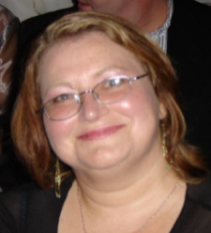



**ANNA CONTACTS**

|  |  |  |  |
| --- | --- | --- | --- |
| **ANNA** | PO Box 193 Surrey Hills Vic 3127 Email: [anna@pams.org.au](mailto:anna@pams.org.au)  Phone: 03 9895 4461 Fax: 03 9898 0249 | | |
| For specific executive enquiries please contact the relevant committee member | | | |
| President | | Sharryn Byers | [president@anna.asn.au](mailto:president@anna.asn.au) |
| Vice President | | Kylie Wright | [vicepresident@anna.asn.au](mailto:vicepresident@anna.asn.au) |
| Treasurer | | Sandra Krpez | [treasurer@anna.asn.au](mailto:treasurer@anna.asn.au) |
| A/Secretary | | Kate Lin | [secretary@anna.asn.au](mailto:secretary@anna.asn.au) |
| Webmaster | | Sharryn Byers | [webmaster@anna.asn.au](mailto:webmaster@anna.asn.au) |
| Conference Convenor | | Linda Nichols &  Leigh Arrowsmith | [conferenceconvenor@anna.asn.au](mailto:conferenceconvenor@anna.asn.au) |
| Journal Editor | | Vicki Evans | [editor@anna.asn.au](mailto:editor@anna.asn.au) |

**We would like to wish all our members a**

**Happy Australasian Neuroscience Nurses Day  
  
4th May, 2016**

On 4 May, 1974, Tonnie Koenen organised the first meeting of Australasian Neuroscience Nurses in Canberra, during the Neurosurgical Society of Australasia's annual meeting. About 30 nurses from the ACT, NSW, TAS, VIC and WA met to formally establish the Australasian Neurosurgical Nurses' Association.

Since that time, Neuroscience nurses have continued to promote collaboration with other nurses and other health professionals in a committed effort to the professional development and education of nurses within the specialty of neuroscience. We celebrate this and the beginning of our Association on our Australasian Neuroscience Nurses Day, every 4th May.

**Annual Australasian Neuroscience Nurses Day Competition**

Submit a report describing how you celebrated Australasian Neuroscience Nurses Day and be in the running to win $100.00 for your ward/unit.

Submit reports to [secretary@anna.asn.au](mailto:secretary@anna.asn.au) **by 30th June 2016**, for your chance to win.

Fun photos --- Snap shot

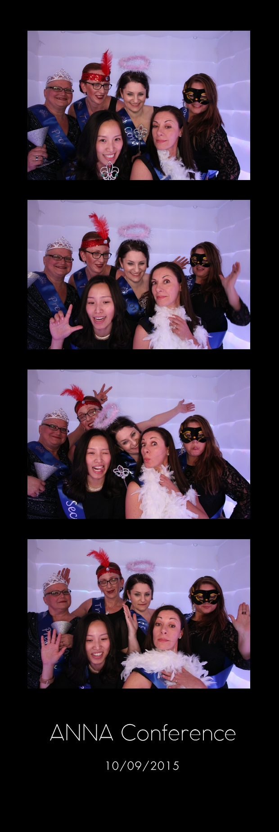 

Australasian Neuroscience Nurses’ Association

Annual Conference 2016

Care and Collaboration



Hilton Hotel, Sydney, Australia • 1 to 2 September 2016

**KEY DATES**

Registrations Open:

**29 March 2016**

Abstract Submissions Open:

**29 March 2016**

Abstract Submissions Close:

**20 May 2016**

Early Bird Registrations Close:

**30 June 2016**

For sponsorship, exhibition and attendance information, please contact:

Website: [www.neuroasm.com.au](http://www.neuroasm.com.au)

Email: [nsa.asm@surgeons.org](mailto:nsa.asm@surgeons.org)

Phone: +61 3 9276 7431

Held in conjunction with the

Neurosurgical Society of Australasia

Annual Scientific Meetin